APPLIED DATA SCIENCE CAPSTONE REPORT

PERFECT PLACE FOR A CHINESE RESTAURANT IN BANGALORE

By Rohan Gudisagar

TABLE OF CONTENTS:

1. Problem Background

2. Problem Description

3. Data Requirements

4. Data Collection

5. Target Audience

6. Methodology

7. Results

Problem Background:

Bangalore, officially known as Bengaluru, is the capital of the Indian state of Karnataka. It has a population of more than 8 million and a metropolitan population of around 11 million, making it the third most populous city and fifth most populous urban agglomeration in India. Located in southern India on the Deccan Plateau, at a height of over 900 m above sea level, Bangalore is known for its pleasant climate throughout the year. Its elevation is the highest among the major cities of India A little more than four in 10 people of Bengaluru are considered migrants, and the percentage of people categorised as migrants has shot up by nearly 12 percentage points in a decade. This was revealed in the recently released Census 2011 data on migration into cities and States.

With 42.12% of Greater Bengaluru’s population originating from outside the district or outside the State, the urban agglomeration ranks second among comparable metros with migrant populations.

Bangalore is known not only as the IT Sector, but also a foodie’s haven. The street food here is amazing, fulfilling, and available at budget friendly prices. The diversity of the cuisine available is reflective of the social and economic diversity of Bengaluru. Roadside vendors, tea stalls, South Indian, North Indian, Arabic food, Chinese and Western fast food are all very popular in the city. Udupi restaurants are very popular and serve predominantly vegetarian cuisine. The Chinese food and the Thai food served in most of the restaurants can be customised to cater to the tastes of the Indian population. Bengaluru can also be called a foodie's paradise because of its vast variety of foods and edibles with a touch of Bengaluru's uniqueness and tradition

Problem Description:

Let us assume that I want to open a Chinese restaurant in the city. Figuring out a place to invest in takes a heavy toll and a thorough research must be done which can take a long time. Many factors play a role here, like the population of the location where the restaurant is to be opened, the existing restaurants and places in and around the area. Hence, there are a few questions that must be addressed before we proceed:

1. Which are has more population?
2. Which area in the city has more facilities and stores, which will attract more crowd?
3. Are there any Chinese restaurants existing in the area?
4. Do the similar restaurants cost more?

To address these questions the restaurant company decides to find a solution and can recommend an apt place for opening a Chinese restaurant in the Bangalore city. The questions that I expect answered from this project are:

1. Which area in the city has more venues? (making it suitable for the restaurant start up)
2. Which location in the city is densely populated.

Data Requirements:

Data requirements are crucial for any project, and especially in this case, where we need the latitudes and longitudes of almost all the boroughs in the city of Bangalore. Data can answer question which are unimaginable and non-answerable by humans because humans do not have the tendency to analyse such large dataset and produce analytics to find a solution.

Let's consider the base scenario:

Suppose I want to open a restaurant in a suitable area, then logically, i need 2 things:

1. Its geographical coordinates (latitude and longitude) of points in the city where there is a possibility of the restaurant to open
2. Population of the neighbourhood where the restaurant is located, which will produce more walk-ins at the restaurant

Let’s take a closer look at each of these:

1. To access location of an area in the city, its Latitude and Longitude is to be known so that we can point at its coordinates and create a map displaying all the venues with its labels respectively.
2. Population of a neighbourhood is very important factor in determining a restaurant's growth and number of customers who turn up to eat. Logically, the more the population of a neighbourhood, the more people will be interested to walk openly into a restaurant and less the population, a smaller number of people frequently visit a restaurant. Also, if more people visit, better the restaurant is rated because it is accessed by different people with different taste. Hence is a very important factor.

Data Collection:

I found online a list of areas in and around the city in the form of the table containing the latitude, longitude, and the area name. After retrieving this table in the script, I produced the data frame as mentioned below:

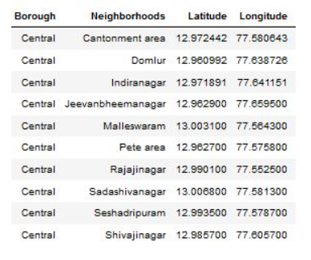

Neighbourhood population is assumed and may be inaccurate but since this is a demonstrating project, the main idea to get the working model. The data frame for Bangalore neighbourhood population looks like:

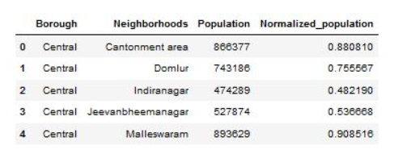

Use of foursquare is focused to fetch nearest venue locations so that we can use them to form a cluster. Foursquare API leverages the power of finding nearest venues in a radius(in my case : 500mts) and also corresponding coordinates, venue location and names.

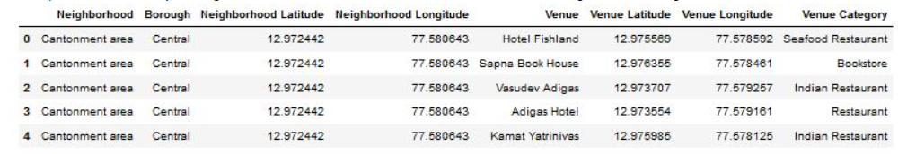

Target Audience:

Target audiences for this project does not limit to a person who wants to open a specific restaurant in the area, but to anyone that’s working on any business idea. This project is open ended to anyone that want to explore the city of Bangalore.

Methodology:

First step was to begin with gathering the data. In this case, it was to gather data about the population of the city, all the areas in the city with their longitude and their latitudes, the income based on the area. After gathering all this data, it was important to sort the out according the importance of the data.

Exploring this data once in a readable format is important, as It gives you an insight about how to procced or in this case begin. The first step was to figure out a suitable location for chinese restaurants. This happened with the help of foursquare API which helped gather all the nearby places which gave insights on which area has most venues, which is beneficial in having a restaurant put up in that area. In our case, Indiranagr was a suitable match.

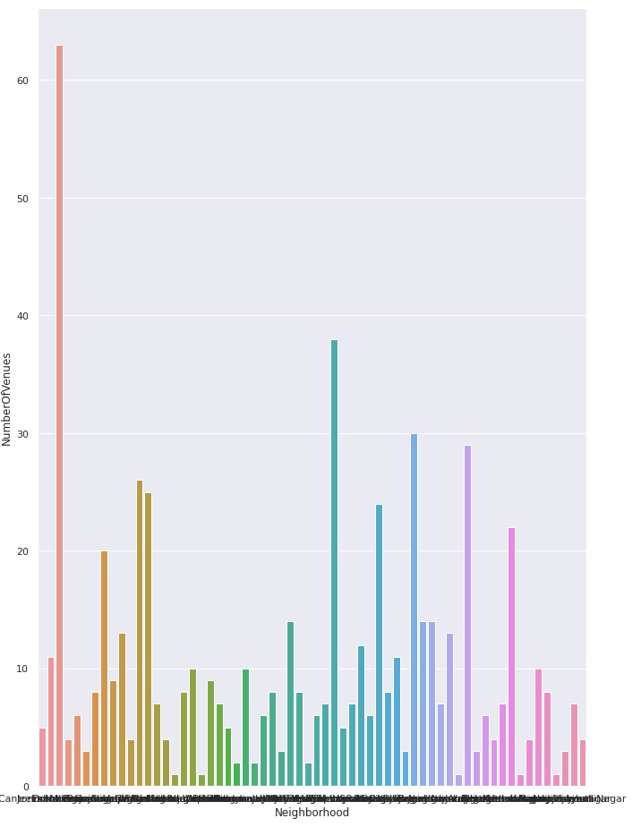

Next, we went on to check which area has more population, which also plays a crucial role in a restaurant business. More the population more the footfall.

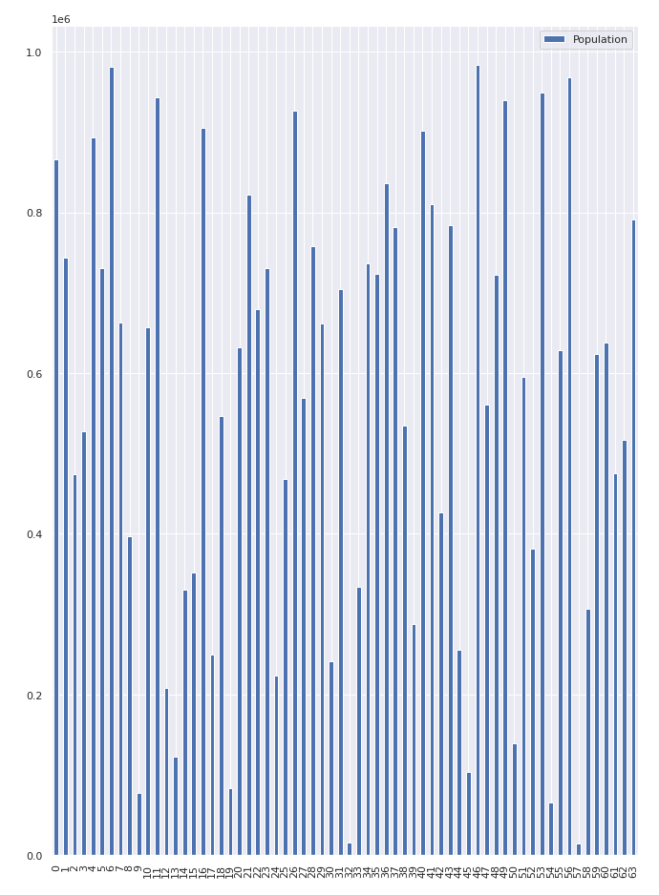

Comparing the population and the venues, Indiranagar was a perfect match to have a restaurant. The next step was to figure out or to build a recommender machine that shows places like Indiranagar in the city, so we have multiple options open to us for the construction of chinese restaurant

This was possible by forming clusters

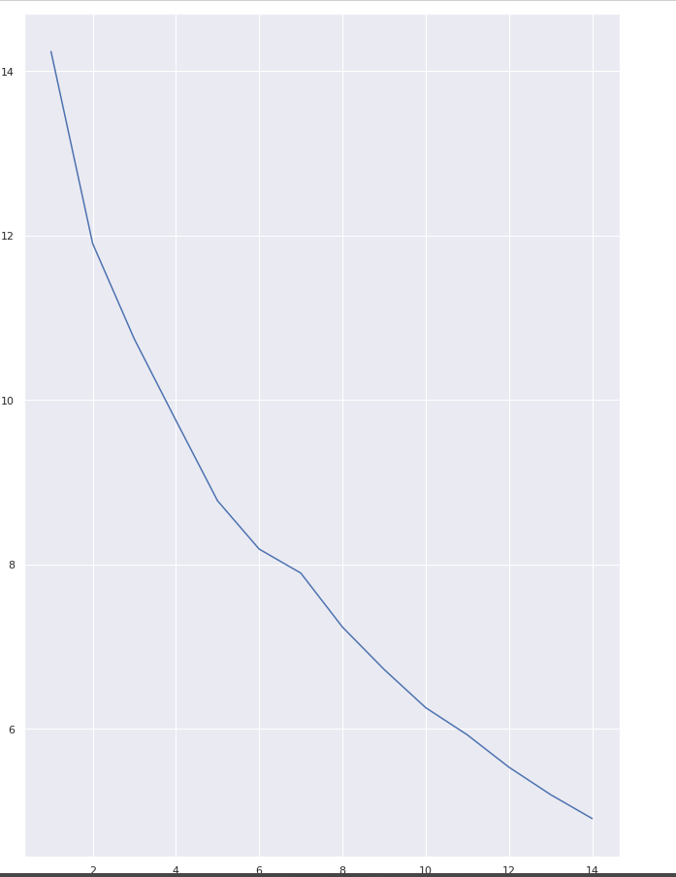

Result:

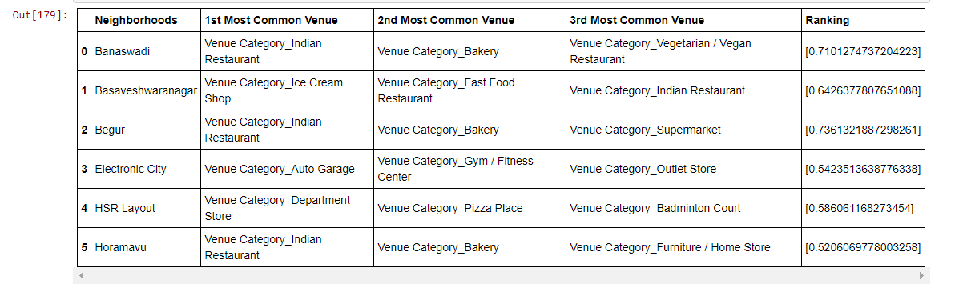

The result shows the top 5 areas where having a restaurant would lead to a profit and can be considered a good idea.